Hotel reservation system

**Domain analysis**

**Introduction**: The domain is “hotel reservation”, the motivation for this domain analysis is to develop a system that automates the process of hotel reservation. We would ask the guest to enter the number of people with him, and number of rooms he wants, rating of the room that he wants, the kind of view it has, the start day and how many days he plans to stay . We would display available rooms bases on the user input, it’s locations, it’s views ,and of course it’s price. We would record of course the customer’s name, phone number and the id.

**Glossary:**

Check in: it’s the process in which a guest provides his identification and reservation.

Check out: it’s the process in which a guest the guest returns their room key or keycard, settles any outstanding charges such as room service or mini-bar fees, and confirms their departure date and time. The front desk agent then checks the room to ensure that there is no damage or missing items, and finalizes the guest's bill

**General knowledge about the domain**:

The process of online travel booking has moved firmly into the 21st century, with an estimated $817 billion worth of online bookings by 2020

in 2019 before the covid, the occupancy rate of the hotels in the us was about 66 %. That’s of course a lot of reservations, check ins and check outs

An estimated 700 million people will make a booking online by 2023 83% of US adults want to book their trips online

Of the 148 million online travel bookings in 2018, 82% occurred without any human interaction, via a mobile app or website.

**Customers and users:**

Hotel guest: he is the one who wants to reserve a room

Hotel reservation admin: he is the one who have access to view all the occupied rooms, the names of the residents, their phone number. He record the reservation on the check in and finalize it on the check out.

**The environment:**  the customer can access the system interface by a pc or a mobile phone.

**Tasks and procedures currently performed:**

1-Inquiries: The first step in reserving a room for a customer is to receive their inquiry either in person, over the phone, or via mail. The hotel clerk would then ask the customer for their desired check-in and check-out dates, room preferences, and other relevant information.

2-Availability check: After gathering the customer's requirements, the hotel clerk would check the availability of rooms for the requested dates by checking a room availability chart or ledger.

3-Room selection: Once the clerk determines the availability of rooms, they would offer the customer their available options based on the customer's preferences. If the customer agrees on a particular room, the clerk would note the selection in the room availability chart or ledger.

4-Booking confirmation: After the room is selected, the hotel clerk would then confirm the booking by filling out a registration card with the customer's name, contact details, check-in and check-out dates, and room rate. The customer would be required to sign the registration card as a confirmation of the booking.

5-Payment and deposit: If required, the hotel clerk would collect a deposit or advance payment from the customer, either in cash or by check, as a guarantee of the reservation. The hotel clerk would then issue a receipt for the payment.

6-Room assignment: On the day of check-in, the hotel clerk would assign the confirmed room to the customer and provide them with a room key.

**Competing software:** Currently there are many competing hotel guest manegment softwares like octorate or RateHawk but they are general systems, the system we are developing is custom for the current hotel so it will have more features relevant only to this hotel.

**Functional requirements**

|  |  |
| --- | --- |
| Requirement ID | Statement |
| FR01 | The software user interface shall have a registration panel in which a user may enter his name and email |
| FR02 | The user shall be prompted to the main menu where some information about the hotel is available including some customer reviews and pictures of the hotel and it’s rooms |
| FR03 | The used shall be prompt a panel asking from the day of check in and check out |
| FR04 | Based on the result of FR03 a menu for all the available rooms will be displayed.  Each room is displayed as follows  -It’s number  -It’s rating  -It’s capacity  -A picture of it  -It’s view  -It’s price |
| FR05 | The user can filter the menu by prices or by ratings or by capacity |
| FR06 | Upon selecting a room the user shall be prompted to fill out a registration form |
| FR07 | The system shall prompt the user to select his way of payment weather it’s  -cash on check in  -by an e-wallet  -A debt card |
| FR08 | The user can cancel the reservation any time but if it’s too late he will have to pay a percentage of the reservation |
|  |  |

**Non functional requirements**

|  |  |
| --- | --- |
| Non-functional req id | Statement |
| Performance | Every panel should take about 3 seconds to load |
| Scalability | The site should support up to 1000 simultaneous users without experiencing a drop in performance |
| Resource usage | -The site shouldn’t use more than 20 mb of the memory  - system must consume less than 1% of the CPU’s time when run on a 1.8GHz machine under a certain operating system. |
| Maintainability | -The code should be well-organized and easy to understand, with clear documentation. -The site should be tested regularly to ensure that it is working properly. |
| Reliability | The server shouldn’t suffer more than one failure in 4 month. |
| availability | The site should be available 95% of the time and it’s down time shouldn’t exceed 20 mins in 20 years span |
| Recovery from failure | The system should be recovered within 14 hours of failure |
| Computing platform | The website should be working on every browser on every operating system |
| Development process | Our approach in the development should be agile |

**Use case model**

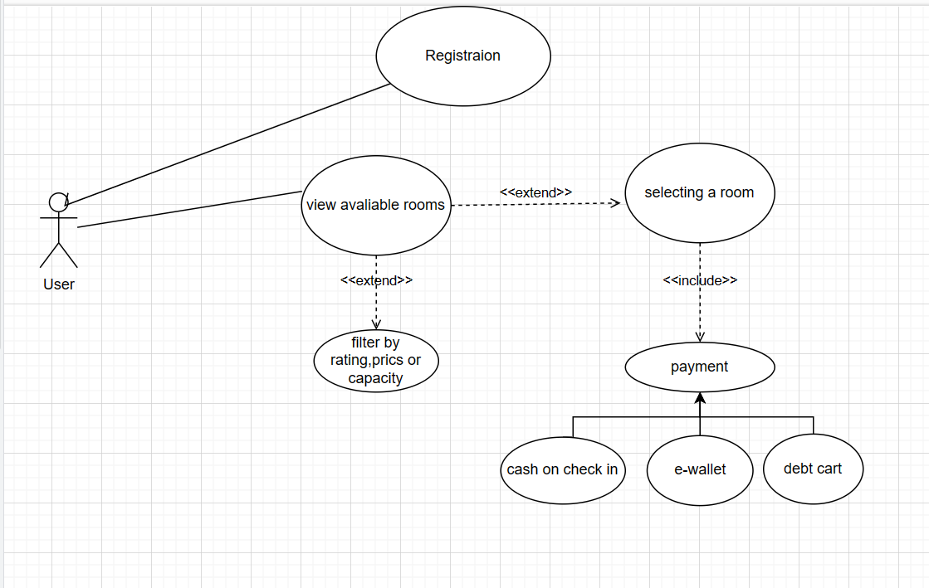

**UML class diagram**

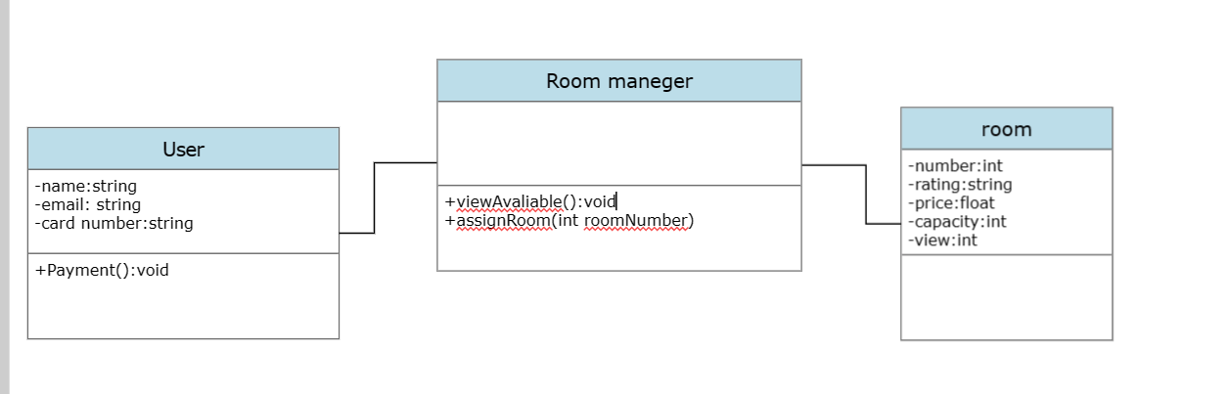

**I used Smart draw for class diagram, diagrams.net for use case model and chat gpt for knowing the manual procedures of hotel reservation.**